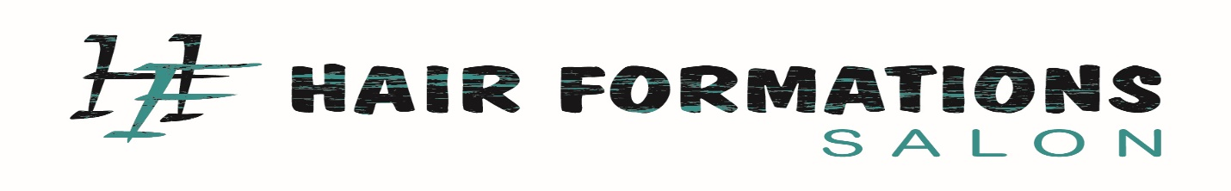
Covid-19 Wavier

I ______________________________ have agreed to receive a salon service from Hair Formations Salon on (mm/dd/yyyy)______________________. I understand that before any service may be performed, I agree to the following:
- To cancel/reschedule my appointment within 24 hours if I am not feeling well for any reason, or if I have been exposed to anyone who has tested positive to Covid-19 in the past 14 days or have or had Covid-19 within the last 14 days.
- To allow Hair Formations Staff to check my temperature upon arriving to the salon. Also allowing Hair Formations to cancel/rescheduling my appointment if my temperature if its above 99.0 degrees.
- To wear a mask while in the salon to protect yourself and members of Hair Formations Salon.
- To agree to any and all charges that are charged by Hair Formations Salon for failing to sign this wavier or failing to timely cancel/reschedule my appointment or for any no calls/no shows.
- To agree to waive and not pursue any claim against Hair Formations should I experience any Covid-19 symptoms or test positive for Coronavirus after receiving services from your salon visit.
Signed, Date: __________________
Client’s Signature _______________________________________________

